Intelligent Vehicle Safety and Tracking System with Automatic Accident Detection and Messaging

Siva Sankar C

Department Of Electrical and Electronics Engineering Knowledge Institute of Technology

Kiot Campus, Kakapalayam, Salem - 637504.

[2k20eee34@kiot.ac.in](mailto:2k20eee34@kiot.ac.in)

***Abstract* —Road accidents are a major concern worldwide , resulting in loss of life, injury, and property damage. In recent years, there has been growing interest in developing intelligent vehicle safety and tracking systems that can help prevent accidents and provide timely assistance in the event of an accident. This paper proposes an Intelligent Vehicle Safety and Tracking System with Automatic Accident Detection and Messaging , which uses GPS module , GSM module , accelerometer and camera machine learning models , cloud servers to detect and prevent accidents. The system can detect accidents automatically and alert authorities , while also providing real-time updates to vehicle owners and emergency responders . The paper describes the design and implementation of the system , as well as the testing and evaluation process . The results demonstrate that the system is accurate , reliable , and effective in detecting accidents and preventing unsafe driving behavior . The proposed system has the potential to significantly improve road safety and reduce the number of accidents, injuries, and fatalities.**

***Keywords— Accelerometer, automatic emergency messaging system, Accident detection , abrupt change in threshold value detector, Arduino , GSM Module , GPS Module Accelerometers , gyroscopes, camera modules***

I. Introduction

Road accidents remain a significant public health concern worldwide, with an estimated **1.35 million deaths** and **50 million injuries** occurring annually , according to the World Health Organization . In the United States alone , the National Highway Traffic Safety Administration reported that there were over **38,000 deaths** and **4.4 million injuries** due to motor vehicle crashes in **2019** . Despite significant improvements in vehicle safety technology , such as airbags and anti-lock brakes , accidents still occur due to factors such as distracted driving , impaired driving , and poor road conditions.

Reasons for road accidents square measure speed driving, drink and drive, not following rule. in keeping with some survey the most reason for deaths within the road accidents is delay in providing emergency services. If the delay are often reduced the person may get saved. For Associate in Nursing accident victim it's terribly tough to alert the police room or the relations concerning the accidents. The projected system is employed to scale back the time delay between the accident and providing emergency services. The vehicle pursuit and accident detection device are often put in in any vehicle. Whenever a vehicle is taken or associate accident happened to the vehicle the coordinates is taken through international positioning system (GPS) module and is regenerate into Google map link through the formula within the microcontroller. The formula is preinstalled within the microcontroller.

.III. Problem statement

Various inquiry reports of road accidents were studied and it had been clear that the key areas on for road accident death was the delay in providing facilitate to the accident victims . The measuring system based mostly transportation planned would inform the police room or accident victim ’s members of the family concerning the accident instantly , in order that facilitate to the livid in road accident may be delivered as presently as attainable . The medical emergency care unit would dis patch to the accident location with none delay , thereby the victim ’s survival possibilities can be increased.

1. RELATED WORKS

The GPS and GSM modules square meas ure used that square measure wont to track the e xact location of the vehicle that ’s missing . this technique is in a full of life mode in each the conditions either the vehicle is in its on or off condition . And if any interruption is occurred in a full of life mode then it 's detected by the IR detector and when sens ing directly it'll send the google map link which can use to hunt out the exact location of the vehicle to the lover of the accidental victim . When obtaining the mes sage owner of that vehicle can replies back and s o the s peed of the engine motor can decrease and moderately s witches off the vehicle and doors square measure attending to be barred [3].

Vehicle to vehicle communication may be a highly regarded s pace of analysis within the transportation field s ystem . Most of the systems are handling this accident detection [4]. At this time varied range of systems are supported GPS and CCT V accident detections

. Accidents is detected on the premise of pres s ure device or frequency . Also , it will dis cover the accidents by the video -bas ed detectors . Accidents will d is cover by the GPS module and s peed etc . are liabilities to possess incorrect alarm and conjointly not thus fruitful

GPS and CCTV based mostly accidents awareness system that encircle GSM to send latitude and line of longitude values however by this values user might not be ready to perceive the GPS mes sage thus these results don't s seem to be of any use for the loved one of accidental victim [ 5]. Mos t of the time the accidents square meas ure detected by the “Radio Frequency “ bas ed mostly detectors that s quare meas ure restricted to a selected space , suppose if it'll leave of vary then this method cannot notice the vehicle [6]. and als o the video-based detection may be a terribly difficult technique [7]

01

Similarly, in [8] author urged that speed-based detectors appear to grant incorrect alert once some disturbances occurred . So, there 's a desire to grow a system with less incorrect alerts and provides out exact location of the vehicle that can als o be comprehensible to the loved one simply and therefore the vehicle following techniques uses GPS system .

Through several application GPS modules area unit used for vehicle chase techniques and everyone these techniques are unit terribly required for track the vehicles and their committee also can monitor the vehicle often [9].

Number of the way area unit obtainable for following a vehicle . Massive scale firms us e net server for following a vehicle and small-scale firms uses differing types of mobile applications . Basically the applications unit developed for locating location distance and shrewd time to realize at a specific destination [10].

It is simple to mention that the exact location of the vehicle will be taken fro m GPS however much it's not possible. In spite of getting a complicated technology it's too troublesome to get the proper coordinate all of the time. Mis treatment Kalman filter it's simple to induce actual line of longitude and latitude values of the vehicle [11]. Everyone is aware of that there are a unit many ways for following the exact location of the vehicle that had met associate in nursing accident. Once accident happens, it's terribly troublesome for the victim to send word the relations , hospitals or police . During this state of affairs associate in nursing alert mess age will be sent to the predefined range within the system [12].

In [13], accident detection mistreatment smart-phone is projected. However, if accident is detected mistreatment mobile, then there's heaps of filters utilized in smart-phone to avoid false alarms. Therefore, detection risk is lower for tiny accidents like strike collision.

In [14], the thought of the system is already bestowed by the authors. In the projected system, multiple unhearable sensors are used for accident detection. an ultrasonic sensing element is employed to live the space.

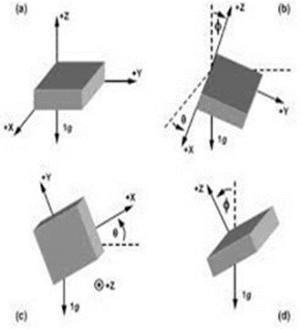

Fig. 2: Axis of Rotation of Accelerometer [4]

1. Implementation & Working

*A. Block Diagram*

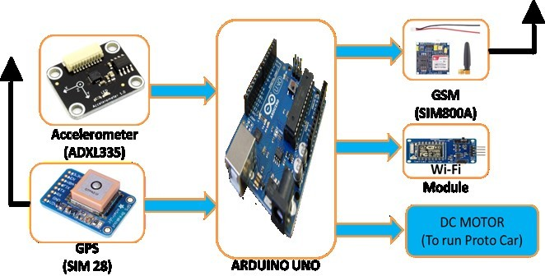

*Fig. 1 : IAMS Based Block Diagram*

*B. Working*

The flow chart of the AMS based mostly System is given within the Fig . 2 . Once the vehicle detects abrupt modification within the thres hold values with the assistance of meas uring device detector , that set the flag little bit of Arduino UNO as before long as accident is detected. Set the effective sens itive value for meas uring ins trument detector , throughout that accident or crash is detected . Once Arduino detects the accident or set bit through meas uring instrument detector , Arduino activates the GSM module that has a manually saved signal of friend of accident victim, sends a pre-stored SMS to that selection.

Simu ltaneously, it further offers the message to the many friends that accident had occurred. This technique is known as automatic emergency message system.

This sys tem is intended to tell regarding associate in nursing accident or crash that had occurred to the members of the family of the move pers ons . AMS sys tem us es a electricity device which could realize the abrupt vibration once ass ociate in nurs ing accident or crash had occurred . This sends a symbol to microcontroller . A GSM equipment is interfaced with the Arduino unit. The GSM equipment s ends ass ociate in nurs ing SMS to the predefined mobile variety and informs regarding the accident.

02

**Current Situation**

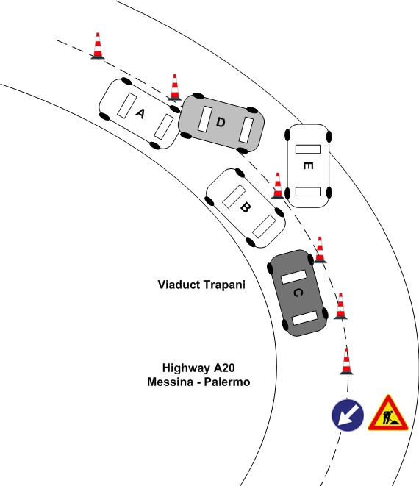

**Fig:4 Current Situation**

**Circuit Diagram**

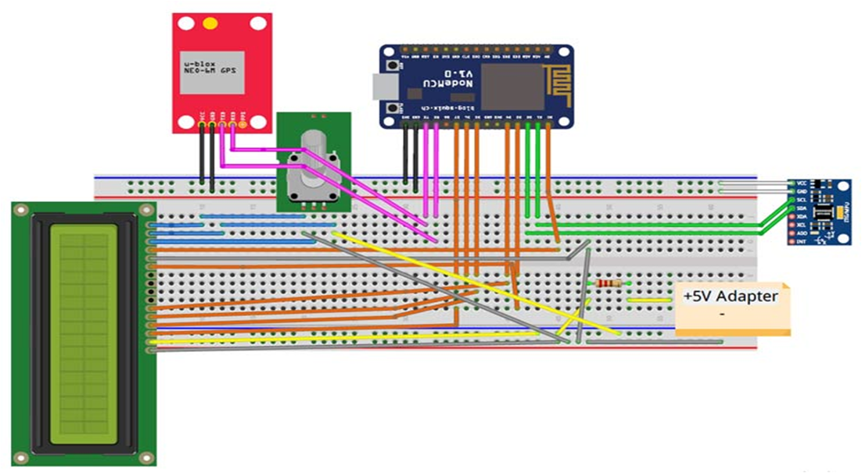

**Fig: 5 Circuit Diagram**

*D. Tables and Graphs*

TABLE I. CONMP ARISION OF safety system with reduction in accidents

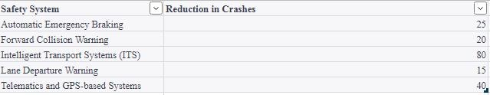

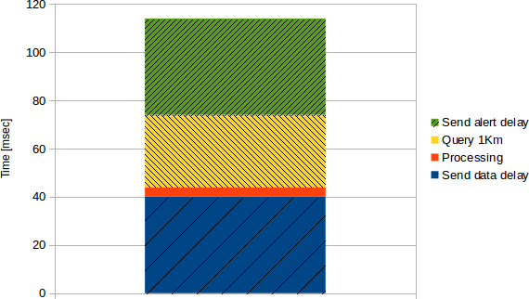

**Graph for Processing Response**

**Flow Chart**

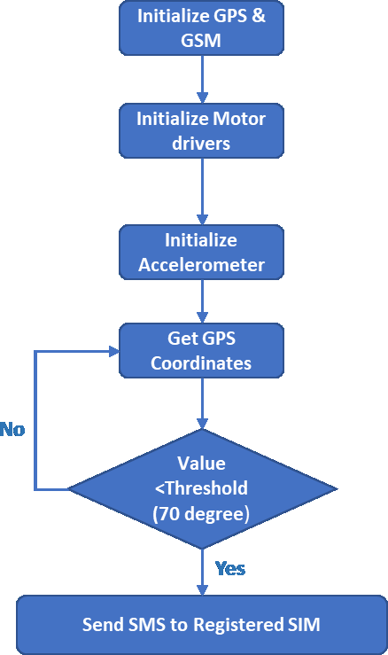

**Fig. 6: Flow Chart of IAMS based System**

03

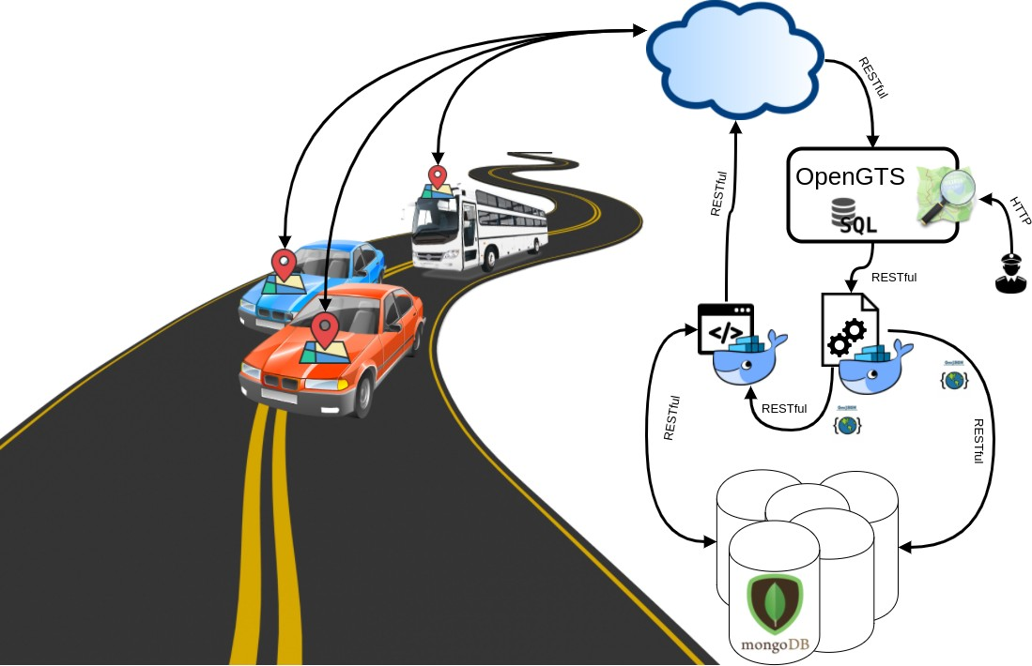**Fig:7 Working Prototype Fig : 10. Working Methodology**

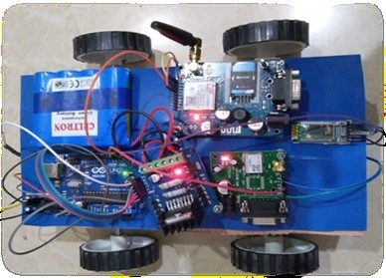

**Fig: 8 Accident Photos**

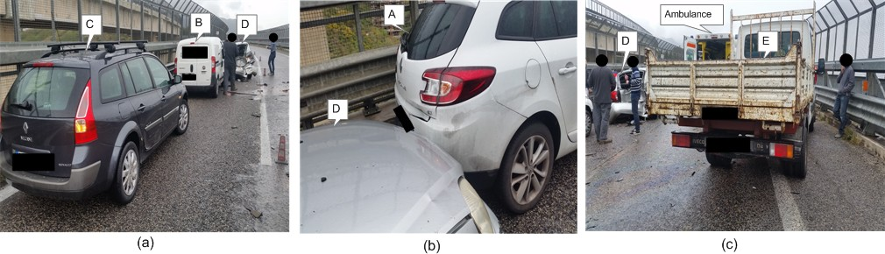

1. 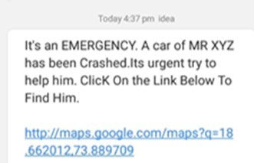RESULTS

The device was tested in rural areas and located that things of the vehicle was e xpected effectively in most of the cases. However, the e xact location link shown at intervals

the message interfaces. **Fig. 11: Message interface of receiver section**

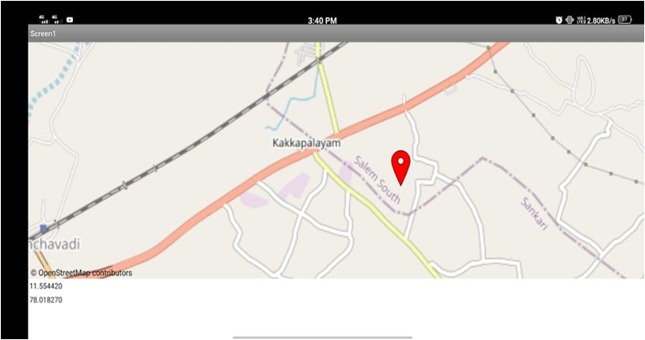

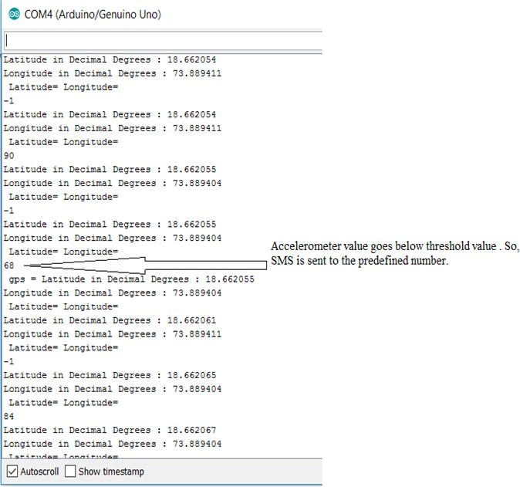**Fig. 10: Accelerometer Output**

**Fig. 12: Real Time Location**

04

1. Conclusion

AMS sys tem will play a s ignificant role within the fie ld of road accidents . By victimization automatic messaging system, it facilitates to the separated person in road accidents as quick as possible. Thereby it increas es the victim’s survival possibilities . If the vehicle co mpany’s tie- up with AMS system, the transmis sion may be used efficiently within the vehicle. For recent vehicle, there need to be Ass ociate in nurs ing option to setup the AMS system in it. The deaths and additionally the severe conditions due to accidents the GSM technologies square meas ure used where the immediate action would be taken by the automobile / police service that might cut back the severity. In future, A Dashboard are going to be created to store a ll the accidents knowledge (drivers driving pattern) which can update to the friend, main road Hospital (res cue team ) and Government Agencies to induce details of accidents.

The AMS system will bro wse the OBD (On-Board Diagnos tic) information which is able to facilitate

**REFERENCES**

1. Government of India, Minist ry of Road Transport and Highways, Lok Sabha Unst arred Quest ion No. 374 Answered on 19 -07-2018
2. F. B. Basheer, J. J. Alias, C. M. Favas, V. Navas, N. K. Farhan and C.V. Raghu, "Design of accident det ect ion and alert syst em for motorcycles," 2013 IEEE Global Humanitarian Technology Conference: South Asia Sat ellite (GHT C-SAS), Trivandrum, 2013, pp. 85-89.
3. R. Ramani, S.Valarmathy, Dr. N Suthant hira, S.Selavaraju, M.

Thiruppat

hi, R.Thagam, “ Vehicle Tracking and Locking Based GSM and GP S”, Issue Dat e: Sept 2013)

1. An Ericsson Whit e P aper,” Communicat ion and Informat ion Services for Nat

ional Security and P ublic Safety”, Ericsson Microwave System AB.I. S. Jacobs and C. P . Bean, “ Fine part icles, thin films and exchange anisotropy,” in Magnet ism, vol. III, G. T . Rado and H. Suhl, Eds. New York: Academic, 1963, pp. 271–350

1. GONG xiaoyan, TANG shuming, WANG feiyue, “Traffic Incident Det ect ion Algorithm Based on Non -paramet er Regression” IEEE 2002.
2. Li Chuanzhia, Hu Rufua, Hang Wenb, He Jieb and Tao Xianglib, “ St udy on

the Met hod of Freeway Incident Det ect ion Using Wireless P osit ioning T erminal” ICICTA on 20-22 Oct. 2008.

1. Rajesh Kannan Megalingam. Ramesh Nammily Nair, Sai Manoj Prakhya

“Wireless Vehicular Accident Detect ion and Report ing Syst em” ICMET on 10 -12 Sept . 2010 M. Young, The Technical Writ er’s Handbook. Mill Valley, CA: University Science, 1989.

1. M. B. I. Reaz, Jubayer Jalil, Md. Syedul Amin, “ Accident Detect ion and Report ing Syst em using GP S, GP RS and GSM Technology” ICIEV on 18-19 May 2012.
2. J.S Bhatia and Pankaj Verma, “ Design and Development of GP S- GSM based t racking syst em with Google map -based monitoring”, IJCSEA, Vol.3, Issue. 3, pp. 3340, 2013.
3. SeokJu Lee, Girma T ewolde and Jaerock Kwon : “Design and Implement at ion Vehicle Tracking Syst em using GP S & GSM /GP RS T echnology and Smartphone Application ”,

IEEE, pp. 353-358, 2014

1. “ Cellular networks for massive IoT,” Ericsson White P aper

, Jan 2016

1. W. Chris Veness, “ Calculate distance and bearing bet ween two Latitude/Longitude points haversine formula in JavaScript”, 2016
2. J. White, C. Thompson , H. T urner, B. Dougherty , and D.

C. Schmidt, “Wreckwat ch: Automat ic traffic accident det ect ion and notificat ion with smartphones,” Mobile Networks and Applications, vol. 16, no. 3, pp. 285–303, 2011

[14 ] U. Khalil , T. Javid , and A. Nasir , “ Aut omatic road accident detection techniques: A brief survey,” in International Symposium on WirelessSyst ems and Networks (ISWSN ). IEEE, 2017, pp. 1–6.

[15 ] P . B. Fleischer , A. Y. Nelson , R. A. Sowah and A. Bremang , "Design and development of GP S/GSM based vehicle tracking and alert syst em for commercial int er-city buses," 2012 IEEE 4th Int ernat ional Conference on Adapt ive Science & Technology (ICAST ), Kumasi, 2012, pp. 1-6

.

[16 ] R. Kannan , R. Nammily , S. Manoj , A. Vishwa , ” Wireless Vehicular Accident Detection and Report ing System ”, Int ernat ional Conference on Mechanical and Electrical Technology (ICMET 2010).

05